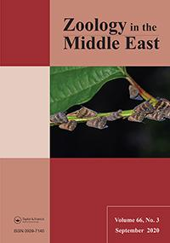**Zoology in the Middle East**

**ISSN: (Print) (Online) Journal homepage:** [**https://www.tandfonline.com/loi/tzme20**](https://www.tandfonline.com/loi/tzme20)



**Distribution and activity period of the invasive *Orosanga japonica* (Melichar, 1898) (Hemiptera:Ricaniidae) in Turkey**

**Ahmet Karataş , Ayşegül Karataş , Nizamettin Yavuz & Murat Genç**

**To cite this article:** Ahmet Karataş , Ayşegül Karataş , Nizamettin Yavuz & Murat Genç(2020) Distribution and activity period of the invasive *Orosanga japonica* (Melichar, 1898)(Hemiptera: Ricaniidae) in Turkey, Zoology in the Middle East, 66:3, 246-252, DOI:

[10.1080/09397140.2020.1793502](https://www.tandfonline.com/action/showCitFormats?doi=10.1080/09397140.2020.1793502)

**To link to this article:** <https://doi.org/10.1080/09397140.2020.1793502>



Published online: 14 Jul 2020.



[Submit your article to this journal](https://www.tandfonline.com/action/authorSubmission?journalCode=tzme20&show=instructions) 



Article views: 23



[View related articles](https://www.tandfonline.com/doi/mlt/10.1080/09397140.2020.1793502) 



[View Crossmark data](http://crossmark.crossref.org/dialog/?doi=10.1080/09397140.2020.1793502&domain=pdf&date_stamp=2020-07-14)



Full Terms & Conditions of access and use can be found at

<https://www.tandfonline.com/action/journalInformation?journalCode=tzme20>

*Zoology in the Middle East,* 2020



Vol. 66, No. 3, 246–252, http://dx.doi.org/10.1080/09397140.2020.1793502

**Distribution and activity period of the invasive *Orosanga japonica***

**(Melichar, 1898) (Hemiptera: Ricaniidae) in Turkey**

Ahmet Karataşa,*, Ayşegül Karataşa, Nizamettin Yavuzb and Murat Gençc

*aDepartment of Biology, Niğde Ö. H. University, Niğde, Turkey; bSociety for the Conservation of Nature and Wildlife, Atakum , Samsun, Turkey; cÇaykur, Tersane Factory Directorates, Derepazarı, Rize, Turkey*

*(Received 16 May 2020; accepted 1 July 2020; first published online 14 July 2020)*

The invasive species *Orosanga japonica* was found at 38 sites in Black Sea coastal zone of Turkey. It was recorded for the first time from the Central Black Sea Region, and for the second time from Western Black Sea Region and in the European part of Turkey. Most localities were close to the Black Sea (<3 km) and situated at altitudes lower than 150 m a.s.l. with the highest records up to 500 m a.s.l. Maximum distance from the sea was in Alemdağ, with c. 15 km, and Erenköy, with c. 10 km. This species is confined in Turkey to the high-rainy and humid coastal zones. Additionally consid-ering cultivated plants, *O. japonica* was found on 18 host plant species, of which 15 were previously not known to be used by the species. Nymphs of this univoltine pest were found between May and July, depending on the weather conditions such as rain-fall and temperature. Adults emerged between early June and mid- September, with the highest density in the second half of August. Eggs were observed from late August to mid-June.

**Keywords:** new record; host plants; Black Sea coast

**Introduction**

The bug *Orosanga japonica* (Melichar, 1898) (Hemiptera) is regarded as an invasive species in the Western Palaearctic Region. It is a major plant pest which causes damage to crops. It was recorded in China, Taiwan and North-East India, and also introduced to Ukraine (Crimea), South Russia (Abkhazia and Krasnodar) and Georgia three decades ago (Avidzba & Bobokhidze, 1982; Dzhashi, Nikolaishvili, & Demetradze, 1982). Re-cently it was reported from southeast Bulgaria and Iran (Gjonov, 2011; Mozaffarian, 2018). The first record of *O. japonica* from Turkey was given by Demir (2009), with samples collected from Rize in 2007 as *Ricania japonica*. It is assumed to have invaded the Eastern Black Sea Region of Turkey from Georgia in 2007 (Arslangündoğ du & Hızal, 2018; Öztemiz, 2018). Most records come from the provinces of Artvin, Rize, and Trabzon, having erroneously been reported as *Ricania simulans* (Güçlü et al., 2010; Ak, Güçlü, & Sekban, 2013, Ak, Güçlü, Eken, & Sekban, 2015; Göktürk & Mıhlı, 2015; Çakır, Şirin, Can, & Kolaylı, 2017), and was recently also found in Düzce, İstan-bul and Giresun provinces (Arslangündoğdu & Hızal, 2018; Demir, 2018; Öztemiz, 2018; Akıner, Beriş, Seyis, Öztürk, Sevgili, & Demir, 2019). The species is well-known to local people and they call it “Japon kelebeği” (Japanese butterfly), “vampir kelebek” (vampire butterfly), “yalancı kelebek” (false butterfly or fake butterfly) or “İsrail güve-si” (Israeli moth).

*Corresponding author. Email: rousettus@hotmail.com

© 2020 Taylor & Francis

Published online 14 Jul 2020

|  |  |
| --- | --- |
| *Zoology in the Middle East* | 247 |

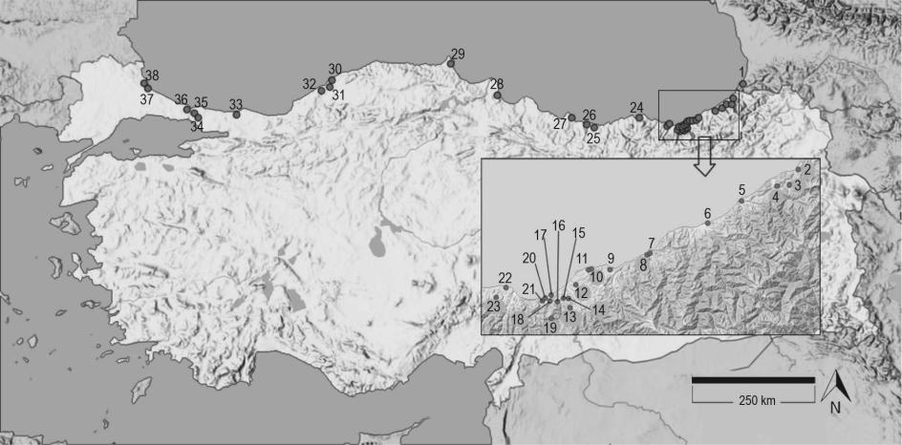

Figure 1. New distribution records of *Orosanga japonica* in Turkey. The numbers are listed in the text under “Material”.

Information on the host plants of this common pest and its predators is limited. Demir (2009) recorded seven host plant species, including eight cultivated plants and blackberry (*Rubus* sp.). Ak et al. (2015) gave elderberry, bean, kiwifruit, wild blackber-ry, bigleaf hydrangea, fig, alder, cherry laurel, tea, and grapevine; adding fern, stinging nettle, hazel, acacia, wormwood, loquat, lavender, trifoliate orange, walnut, date-plum, apple, mandarin, chestnut, cucumber, and eggplant as host plants. Most of them were agricultural plants, namely vegetables and fruits. Arslangündoğdu and Hızal (2018) listed 22 host plant species, also mostly cultivated species. Demir (2018) added *Plata-nus orientalis* and *Clematis vitalba* to the list of host plants.

We provide here new data on the distribution of *Orosanga japonica* in Turkey to-gether with new information on host plants and its seasonal cycle.

**Methods**

This study is based on faunistic observations in Turkey between 2009 and 2019. Eggs, nymphs and adults of *Orosanga japonica* were photographed for species identification. The egg period has been followed by one of the authors (M. G.) at regular intervals throughout the year at Derepazarı (locality 9). Activity periods of both nymphal and adult stages were determined ac-cording to field observations and interview with tea farmers. Density was assessed in three groups according to the number of individuals seen in a plant: (a) 1-5, (b) 6-20, and (c) more than 20 individuals.

**Material**

GEORGIA: [1]. *Ajaria*: Batum, 14.viii.2015 (A. Şeker). – TURKEY: [2]. *Artvin*: Hopa,

08.vii.2009 (A. Karataş), [3]. Arhavi, Derecik Village, vi-viii.2019; [4]. *Rize*: Fı ndıkl ı, Aksu Quarter, 02.viii.2017 (B. Hatinoğlu), [5]. Ardeşen, 03.ix.2017 (H. Deniz Mısır), [6]. Çayeli, Büyük Cafer Paşa Quarter, 10.vii.2016 (M. Genç), [7]. Limanköy Village, 27.viii.2018 (A. Karataş), [8]. Rize (centrum), 26.vii.7018 (M. C. Sancar), [9]. Derepazarı, Tersane Quarter and Çaykur tea factory, 23.viii.2017, 11.ix.2017, 20.ix.2017, 12.ix.2019 (M. Genç, A. Karataş), [10]. Çalışkanlar Quarter, 12.ix.2017 (M. Genç), [11]. İyidere, Yaylacılar Village, 28.vi.2019 (B. Hat-inoğlu); [12]. *Trabzon*: Of, Tavşanlı Village, 20-29.viii.2019, [13]. Kavakpınar Village,

248 *A. Karataş et al.*

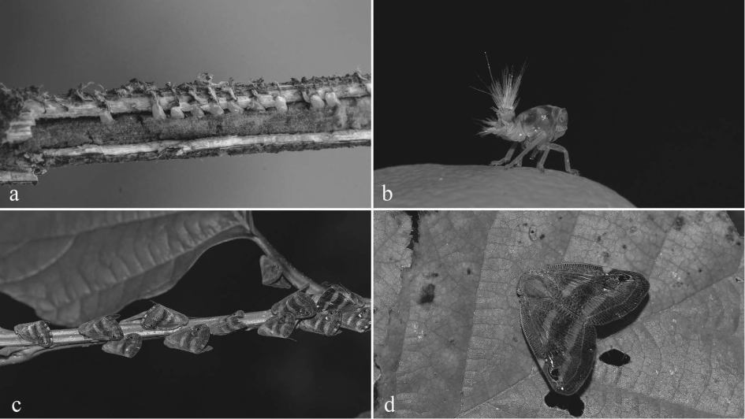

Figure 2. Eggs of *Orosanga japonica* from Derepazarı (a), nymph from Hopa (b) and adults from Çayeli (c) and Bulancak (d) of *Orosanga japonica* (Photo: a. Murat Genç, b-d. Ahmet Karataş).

20-29.viii.2019, [14]. Yemişalan Village, 20-29.vii.2019, [15]. Dumlusu Village, 20-29.vii.2019,

1. Soğukpınar, 20-29.vii.2019, [17]. Yazlık Village, 20-29.vii.2019, [18]. Erenköy Village, 20-29.viii.2019, [19]. Sürmene, Çamburnu, 20-29.vii.2019, [20]. Yeniay Village, 20-29.vii.2019,
2. Araklı, Yalıboyu Village, 20-29.vii.2019, [22]. Arsin, Çiçekli Village, 20-29.vii.2019, [23]. Yomra, İkisu Village, 20-29.vii.2019 (V. Kahraman), [24]. Vakfıkebir, Kirazlık Village, 03.viii.2019 (B. Biçici); [25]. *Giresun*: Bulancak, Samugüney Village, 29.viii.2017; 22.viii.2018;

08.viii.2019 (A. Karataş), [26]. Piraziz, 20.vii.2018 (A. C. Karataş); [27]. *Ordu*: Kumbaşı Village,

08.viii.2018 (O. Akçay); [28]. *Samsun*: Ondokuzmayıs, 15.viii.2019 (N. Yavuz); [29]. *Sinop*

(centrum), 05.vi.2012 (H. Yaşayacak); [30]. *Bartın*: Amasra, 26.vii.2019 (K. Kaya), [31]. Bartın (centrum), 09.viii.2016 (H. Yaşayacak), [32]. Arıönü Village, Mugada Beach, 20.ix.2017 (F. Eren); [33]. *Kocaeli*: Kandıra, 27.vii.2018 (F. Sulak); [34]. *İstanbul*: Çekmeköy, Alemdağ, 20.viii.2012 (A. Verün), [35]. Beykoz, 09.viii.2014 (A. Taşçı), [36]. Sarıyer, 01.ix.2019 (U. Gün-gör); [37]. *Kırklareli*: Vize, Kastro (Çamlıkoy) Bay, 13.viii-02.ix.2019, [38]. Kıyıköy, 13.08-02.ix.2019 (N. Yavuz).

**Results**

**Distribution.** Our first observation of*Orosanga japonica*was in July 2009, when weobtained nymphs from Hopa district of Artvin province, bordering with Georgia (locali-ty 2, Figure 1). In that period, we did not detect the species in the provinces of Eastern Black Sea. Three years later, the pest has established populations in Sinop (locality 29) and İstanbul (locality 34) areas. In 2019, it was found as far west as in Kıyıköy (locality 38), close to the Turkish border with Bulgaria. Altogether, we found the species at 38 different localities along the Black Sea coast of Turkey and also in Georgia (Figure 1). According to this information, the invasive pest rapidly increased its range in this new distribution area.

According to our observations, *O. japonica*is found inthehigh-rainyand humid coastalzone oftheTurkey,apart of boreal(Euro-Siberian) subregionzoogeographical-ly. Its localities were usually less than 3 km from the Black Sea coast line. The location most distant from the sea was Alemdağ (locality 34), with c. 15 km from the İstanbul

|  |  |
| --- | --- |
| *Zoology in the Middle East* | 249 |

Table 1. Natural host plants of *Orosanga japonica*, recorded in this survey. New host species for Turkey are marked with asterisk (*). Density are assessed into three categories: (a). 1–5, b. 6–20, c. >20 individuals on the shoots of the plant.

|  |  |  |  |
| --- | --- | --- | --- |
| **Order** | **Family** | **Species** | **Density** |
| Polypodiales | Athyriaceae | *Athyrium filix-femina* (L., 1753) Roth, 1800* | a |
|  | Dennstaedtiaceae | *Pteridium aquilinum* (L., 1753) Kuhn, 1879* | a |
| Caryophyllales | Amaranthaceae | *Amaranthus* sp.* | b |
| Sapindales | Simaroubaceae | *Ailanthus altissima* (Mill., 1768) Swingle, 1916* | c |
| Malpighiales | Euphorbiaceae | *Acalypha australis* L.* | b |
| Fagales | Betulaceae | *Alnus glutinosa* (L., 1753) Gaertn., 1790* | c |
|  |  | *Corylus maxima* Mill., 1768* | b |
|  |  | *Corylus avellena* L., 1753 | b |
| Rosales | Cannabaceae | *Cannabis sativa* L., 1753* | b |
|  | Rosaceae | *Mespilus germanica* L., 1753* | a |
|  |  | *Rosa* cf. *canina* L., 1753 | a |
|  |  | *Rubus canescens* DC., 1813* | a |
|  |  | *Rubus hirtus* Waldst. & Kit., 1805* | a |
|  | Urticaceae | *Urtica dioica* L., 1753* | a |
| Asterales | Asteraceae | *Artemisia verlotiorum* Lamotte, 1876* | a |
|  |  | *Conyza bonariensis* (L., 1753) Cronquist, 1943* | a |
| Dipsacales | Adoxaceae | *Sambucus ebulus* L., 1753* | c |
| Liliales | Smilacaceae | *Smilax excelsa* L., 1753* | a |

Strait and Erenköy Village (locality 18), with c. 10 km from the Black Sea.This species was mostly found at altitudes lower than 150 m a.s.l., with the highest records up to500 m a.s.l.in the villages of Tavşanlı (locality 12) and Erenköy (Trabzon: Of) (Figure 1).

**Host plants.** In addition to agricultural vegetable and fruit plants like maize, bean, cu-cumber, tea, mulberry, fig, and kiwifruit where a high density of 20 individuals per plant were recorded, 18 plant species from 12 families of nine orders were determined as host plants of this polyphagous insect. Sixteen species were new host records (Table 1).

**Activity period.** *Orosanga japonica*is univoltine, and nymphs (Figure 2) were foundfrom mid-May to mid-July, depending on the weather conditions such as rainfall and temperature. Adults emerged between early June and mid-September, with the highest density in the second half of August. After the first eggs of adults were observed to be laid at the end of August, the eggs that followed continued to be detected until the mid-June (Figure 3).

The activity period of adult *O. japonica* started on June 5th (in 2012) and lasted un-til September 20th (in 2017). According to these data, the activity period extends from early June to the third week of September. About half of all records (45%) were from August. The first eggs were observed at the end of August (in 2018). The first nymphs emerged in second half of May and their metamorphosis was completed by the first week of July.

At all localities, *O. japonica* was seen in swarms of hundreds of individuals, espe-cially in tea plantation areas, in the east of Bulancak (Giresun Prov.). Adults feed upon fresh leaves and shoots of trees and scrubs, and they produced a second generation at the end of the summer.

**Predators.** Due to the near-absence of natural predators in this new geography of thisinvasive alien planthopper, its population size and range increases every year. We found only a few predators: one of them was *Iduna caligata* (Lichtenstein, 1823), which is a

250 *A. Karataş et al.*

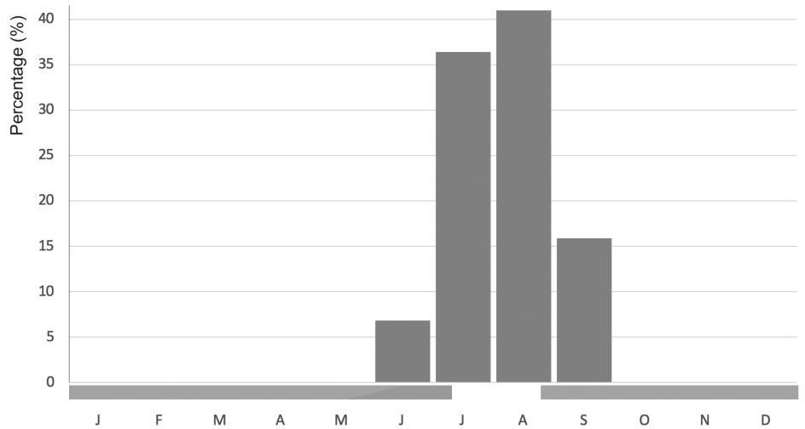

Figure 3. The frequency of observations of adult *Orosanga japonica* between 2009 and 2019. The pink bar indicates egg period and green bar shows nymph period.

rare passage passerine bird species from the family Acrocephalidae (Figure 4). We also determined that some spider species (e.g. *Argiope bruennichi* (Scopoli, 1772)), a pray-ing mantis *Mantis religiosa* (Linnaeus, 1758) (Mantoidea: Mantidae) and a dragonfly *Orthetrum brunneum* (Fonscolombe, 1837) (Odonata: Libellulidae) were predators ofthe planthopper (Figure 4).

**Discussion**

We found *O. japonica* at one locality in Georgia and 38 localities in Turkey, with the first records for the provinces of Bartın, Kocaeli, Kırklareli, Ordu, Samsun, and Sinop. In line with the findings of Arslangündoğdu and Hızal (2018), Demir (2018) and Ak ıner et al. (2019), these data show that this invasive planthopper spreads along the Black Sea zone rapidly.

Our findings on the activity period are similar to those obtained from Eastern Black Sea by Ak et al. (2015) and from Sarıyer (İstanbul) by Arslangündoğdu and Hızal (2018). Ak et al. (2015) reported that nymphs of the pest appear in mid-May and they finish five nymphal stages up to mid-August, the adults emerge in early July and start to lay their eggs in early August, overwinter as eggs and give one generation in a year. Similarly, Arslangündoğdu and Hizal (2018) found adults from early July to late Sep-tember in 2015, and from early July to mid-October in 2016. In our study, adults were detected from the beginning of June to mid-September. Both Ak et al. (2015) and Arslangündoğdu and Hizal (2018) identified the beginning of the egg period for mid-August (in 2015) or the end of August (in 2016) and recorded the nymphs from the beginning of May to mid-July (in 2015) or end of July (in 2016). Göktürk and Mıhlı (2015), who used light and sticky traps to catch the species in Hopa in 2013 and 2014, found that the number of adults was highest in the second half of July and the first half of August. The upward trend, which has continued since the beginning of July, declines to the lowest level in early September. These are similar to our results, with the excep-tion of adults in June.

|  |  |
| --- | --- |
| *Zoology in the Middle East* | 251 |

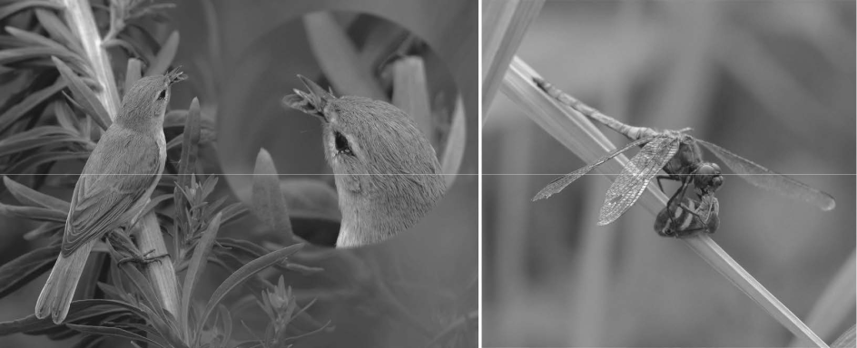

Figure 4. Booted Warbler *Iduna caligata* and Southern Skimmer ( *Orthetrum brunneum*) are two of the relatively uncommon predator species of *Orosanga japonica* (Photo: Birol Hatinoğlu).

Demir (2009) reported blackberry (*Rubus* sp.) and Ak et al. (2015) listed elderberry, wild blackberry, alder, fern, and stinging nettle from natural plants as host plants. In this study, we identified two fern species (*Athyrium filix-femina* and *Pteridium aquilinum*), one alder (*Alnus glutinosa*), one elderberry (*Sambucus ebulus*), stinging nettle (*Urtica* *dioica*), and two blackberry species (*Rubus canescens* and *R. hirtus*) as hosts. These andother species (see Table 1) were reported as new host plant species, which shows that the species changes preference also towards not cultivated plants.

**Acknowledgements**

Our special thanks to Dr. Max Kasparek for comments on the manuscript, Assoc. Prof. Dr. Kiraz Erciyas-Yavuz and Prof. Dr. Raşit Bilgin for editing the English style, and Ahmet Taşçı, Ahmet Verün, Ali Şeker, Alpay Cafer Karataş, Birol Hatinoğlu, Bülent Biçici, Fahri Sulak, Furkan Eren, Hasan Yaşayacak, Hülya Deniz Mısır, Kadri Kaya, Mehmet Hanay, Okan Akçay, Umut Güngör, and Veysel Kahraman for their valuable contributions in field studies.

**Disclosure Statement**

No potential conflict of interest was reported by the authors.

**References**

Ak, K., Güçlü, Ş., & Sekban, R. (2013). Doğu Karadeniz Bölgesi'nde yeni bir zararlı *Ricania* *simulans* (Walker, 1851) (Hemiptera: Ricaniidae)’a karşıazadirachtin ve spinosad etki mad-deli biyopestisitlerin etkinliklerinin belirlenmesi [Determination of the effectiveness of bi-opesticides having active ingredients azadirachtin and spinosad against a new harmful *Ri-cania simulans* (Hemiptera: Ricaniidae) in the Eastern Black Sea Region of Turkey] [in Turk-ish]. *Tarım Bilimleri Araştırma Dergisi*, *6*, 10–14.

Ak, K., Güçlü, Ş., Eken, C., & Sekban, R. (2015). Türkiye için yeni bir zararlı *Ricania simulans* (Walker, 1851) (Hemiptera: Ricaniidae) [*Ricania simulans* (Walker, 1851) (Hemiptera: Ri-caniidae) a new pest for Turkey] [in Turkish]. *Türkiye Entomoloji Dergisi*, *39*, 179–186.

Akıner, M., Beriş, F., Seyis, F., Öztürk, M., Sevgili, H., & Demir, E. (2019). Annual variation of the *Orosanga japonica* Melichar 1898 (Hemiptera: Ricaniidae) populations in the eastern Black Sea region of Turkey and possible molecular separation with based on 28S rDNA se-quences from other Ricaniidae groups. *Plant Protection Bulletin*, *59(4)*, 11–19.

252 *A. Karataş et al.*

Arslangündoğdu, Z., & Hızal, E. (2018). New distribution area and host plants for invasive alien insect species, *Orosanga japonica* (Melichar) in Turkey (Hemiptera: Ricaniidae). *Entomolog-ica Americana*, *124*, 26–30.

Avidzba, N. S. & Bobokhidze, Z. M. (1982). Biophenology of the Japanese leafhopper. [in Rus-sian]]. *Zashchita Rastenii*, *6,* 1–36.

Çakır, H. E., Şirin, Y., Can, Z., & Kolaylı, S. (2017). Doğu Karadeniz Bölgesi salgı balını n karak-teristik özellikleri [Characteristic features of honeydew honey that produced at Black Sea Re-gion] [in Turkish]. *Arıcılık Araştırma Dergisi*, 9(1), 24–31.

Demir, E. (2009). *Ricania* Germar, 1818 species of Western Palaearctic Region (Hemiptera:

Fulgoromorpha: Ricaniidae). *Munis Entomology & Zoology*, *4*, 271–275.

Demir, E. (2018). The economically important alien invasive planthoppers in Turkey (Hemiptera:

Fulgoromorpha). *Acta Entomologica Slovenica*, 26, 233–242.

Dzhashi, V. S., Nikolaishvili, A. A., & Demetradze, T. Y. (1982). The Japanese leafhopper – a pest of bay [in Russian]. *Zashchita Rastenii*, *2,* 1–57.

Gjonov, I. (2011). *Ricania japonica* Melichar, 1898 – a representative of family Ricaniidae (Ho-moptera, Fulgoromorpha), new to the fauna of Bulgaria. *ZooNotes*, 23, 1–3.

Göktürk, T., & Mıhlı, A. (2015). Doğu Karadeniz sahil şeridinin önemli zararlısı *Ricania simu-lans* (Walker,1851) (Hemiptera: Ricaniidae)’ın mücadelesi üzerine araştırmalar [Investiga-tions on struggling with *Ricania simulans* (Walker) 1851 (Hemiptera: Ricaniidae) an im-portant pest of the Eastern Black Sea Coastlines] [in Turkish]. *Artvin Coruh University Jour-nal of Forestry Faculty*, *16*, 89–93.

Güçlü, Ş., Ak, K., Eken, C., Akyol, H., Sekban, R., Beytut, B., & Yıldırım, R. (2010). Patho-genicity of *Lecanicillium muscarium* against *Ricania simulans*. *Bulletin of Insectology*, *63*, 243–246.

Mozaffarian, F. (2018). An identification key to the species of Auchenorrhyncha of Iranian fauna recorded as pests in orchards and a review on the pest status of the species. *Zootaxa*, *4420*, 475–501.

Öztemiz, S. (2018). *Ricania japonica* (Hemiptera: Ricaniidae): Found in the Western Black Sea, Turkey. *Munis Entomology & Zoology*, *13*, 326–328.